Part One: RPT
- User Load
Number of users: 20 -------------- 并发用户数20
Stage Duration: 180 mins -------------- rpt跑schedule总时间， 3h
Rate of Change: 5 mins -------------- 5分钟之内用户数逐渐增加到20个 （for 系统 warm-up）
Settle Time： 30 mins -------------- 5分钟用户加载到20之后， settle time 30分钟等待，系统warm-up [JIT - Just in time： 请求会自动出发系统warm up （缓存?) ]

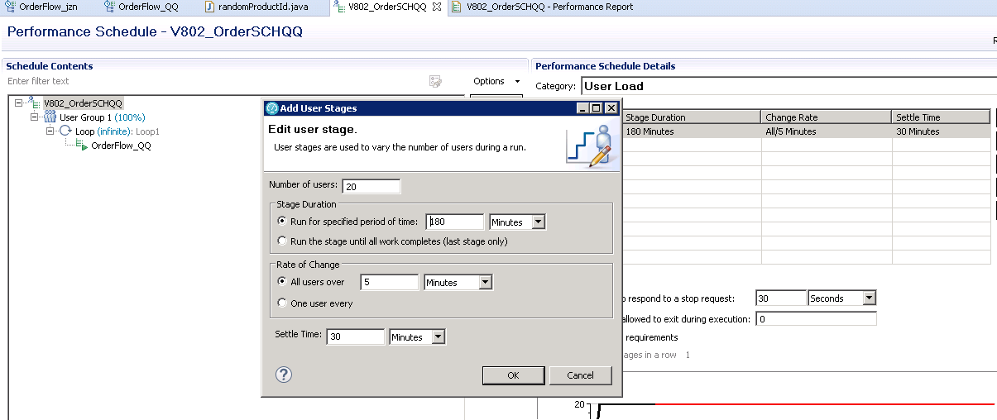

- Think Time
stress test：(1) think time 设置为"0" + "Specify a fixed think time" (2) 每个request之间的Delay，设置为“0”
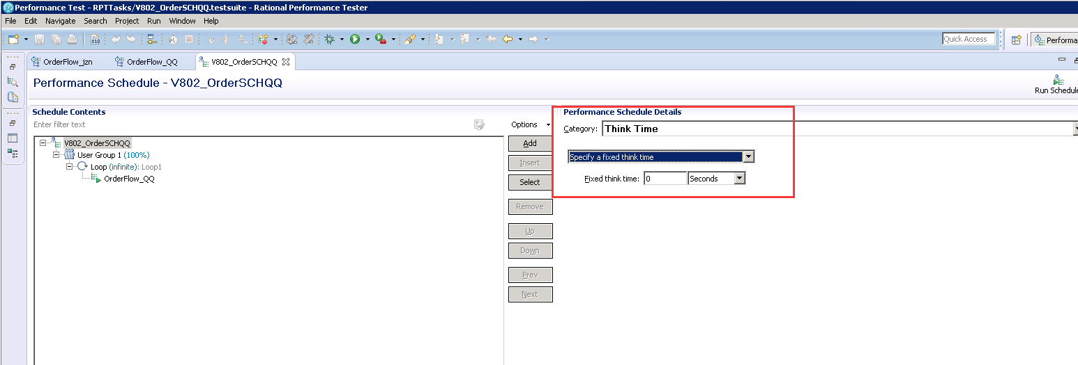

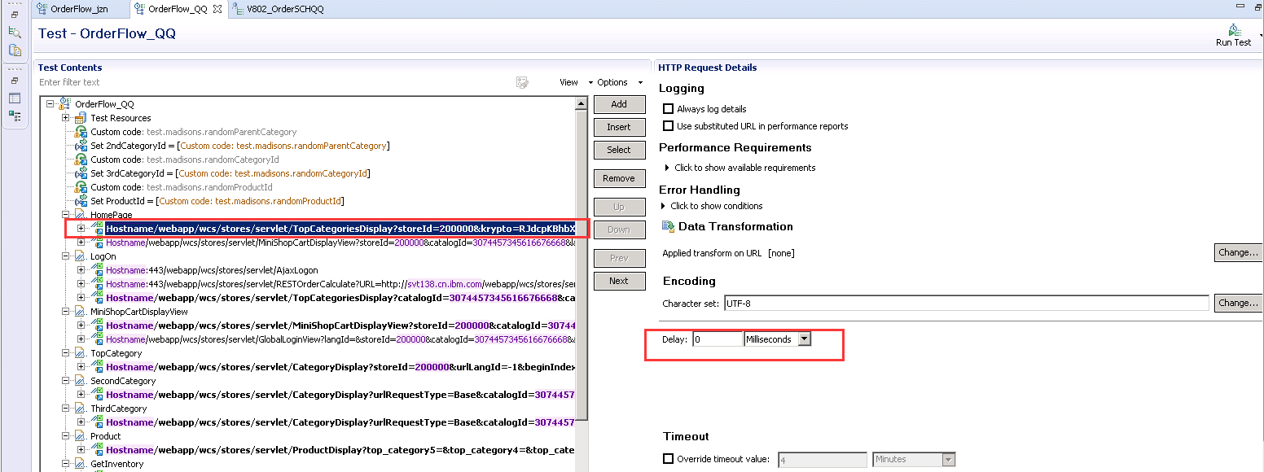

- Log Level
Note: set the minimum log level
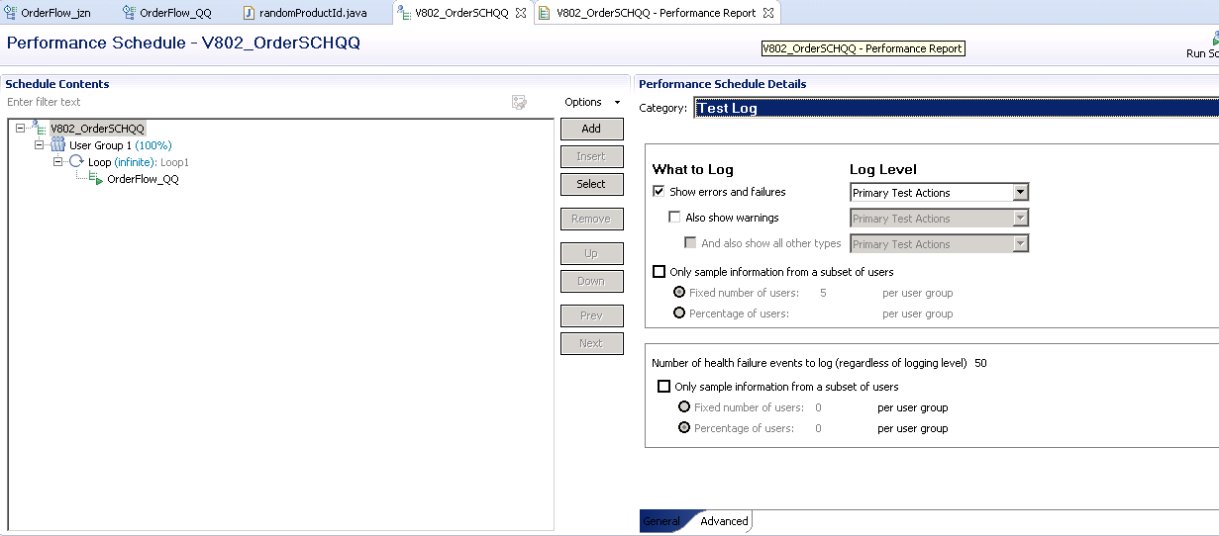

Part Two: WC server (All in one)

- VM standard variable: 4core/16G/dedicated
Note: before running rtp, make vm use dedicated cores and memories

- tunning system
http://www.ibm.com/support/knowledgecenter/SSZLC2_8.0.0/com.ibm.commerce.admin.doc/refs/rpmdefaulttunable.htm

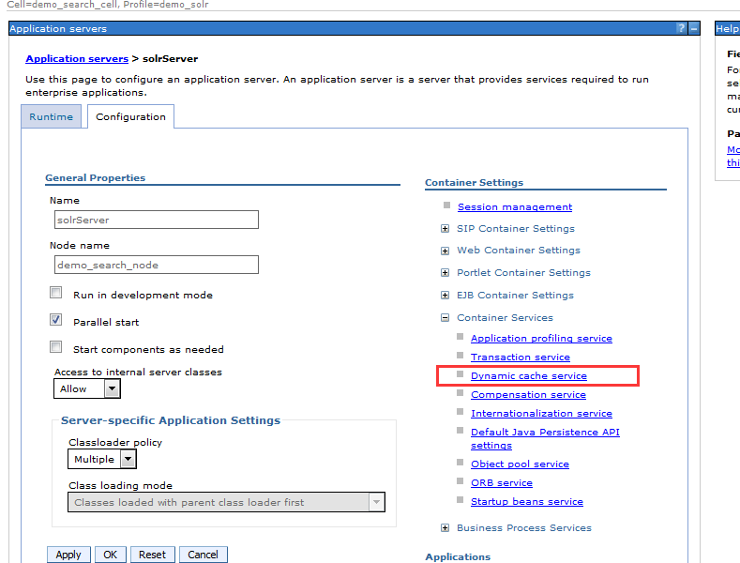

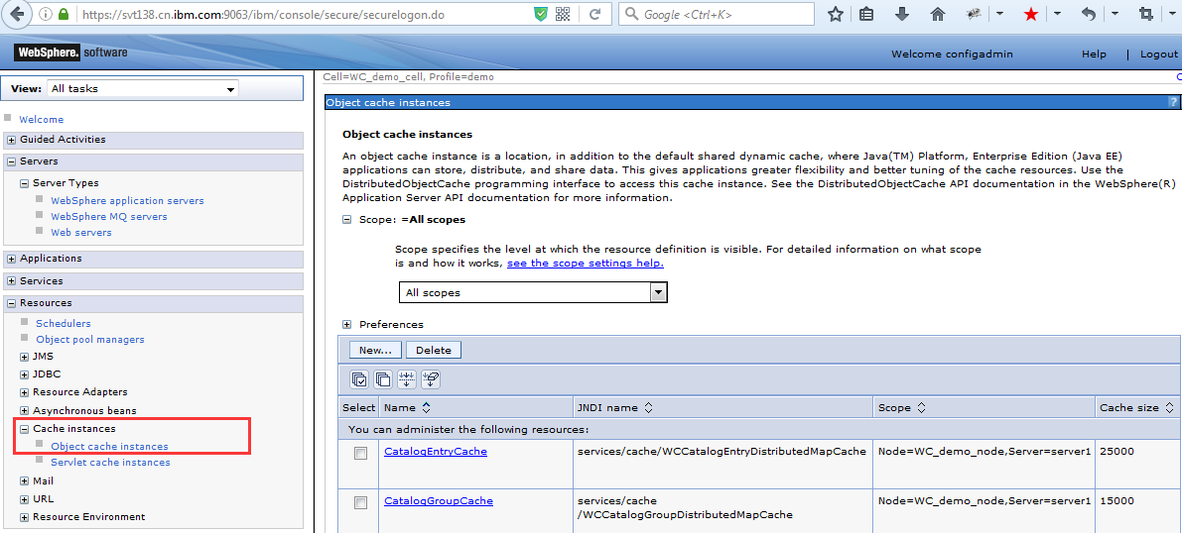

- change log size
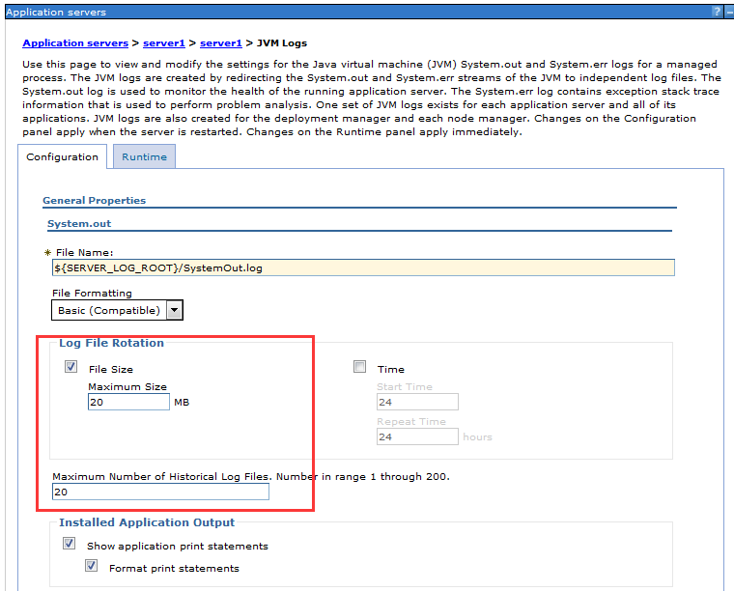

- DB & index tuning
> db2inst1
修改目录权限
./db2v9.sh mall
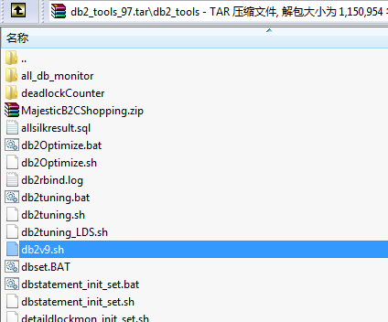

Part Three: Note & Learning & Summary

- Note: If will run the order flow stress tests, we should disable the ValidateOrderPITotalAmount.

/opt/WebSphere/AppServer/profiles/demo/installedApps/WC_demo_cell/WC_demo.ear/xml/config/com.ibm.commerce.order/wc-admin-component.xml

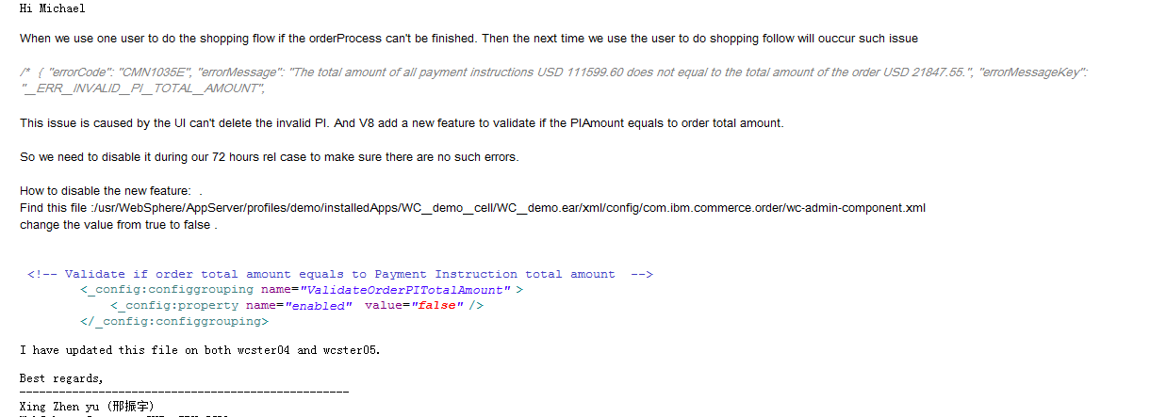

- nmon -> Net -> 网卡写速度 200-300 正常

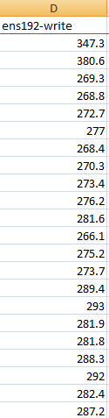

- Findings: (Defect)
Env: 8020RTxLinux64DB2BVT160627_GMV5 (local & all in one)
redhat7.4 4core/16g/100G (Used 43G; Available 53G)

Problem: stress time (think time = 0; user = 20; RPT: change rate 5min, settle time 30min, stage duration 180min )
(1) CPU can not be pushed very high (only 30% arount)
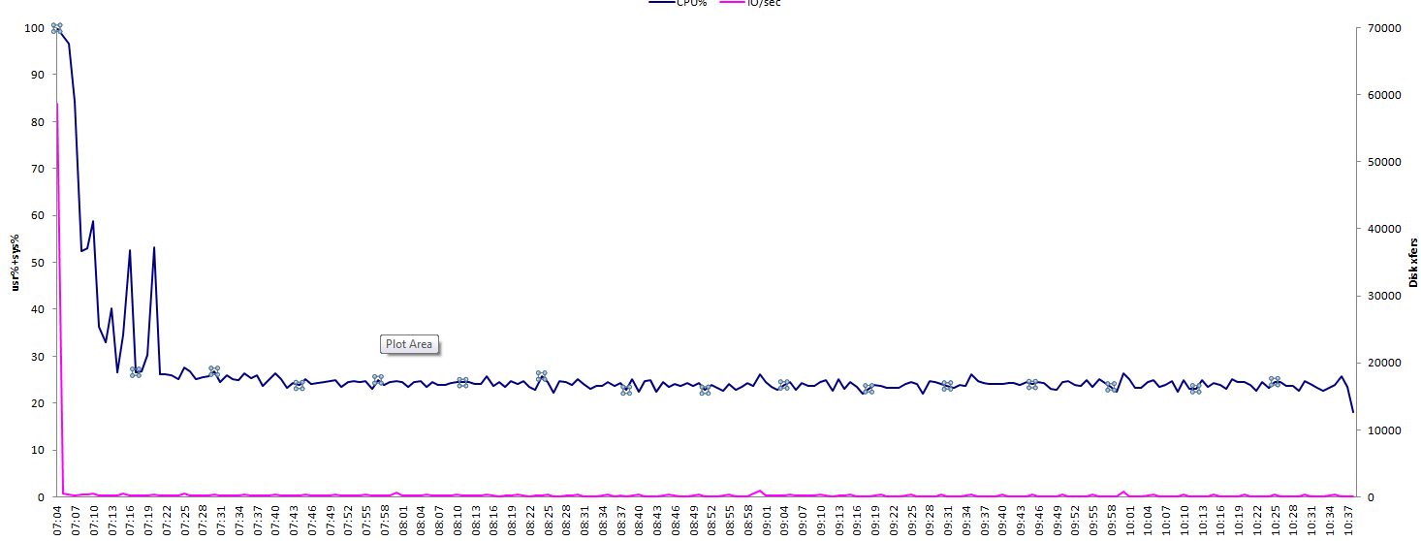

(2) Response time : logon/OrderConfirmation/OrderSummary is high

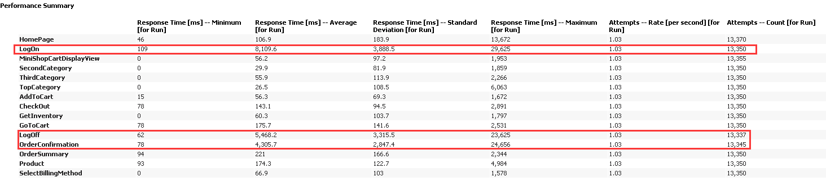

Analysis:
The logon response time is very high. This could may the request per sec is low. The cpu can not be pushed very high.

Method:
- Run RTP to send requests to WC server in order to load stress. In the meantime, catch javadump file in wc server 3 times every 5s.
kill -3 <pid>

javadump.sh

kill -3 6826;
sleep 5;
kill -3 6826;
sleep 5;
kill -3 6826

- Use IBM Thread and Monitor Dump Analyzer for Java to catch java thread core
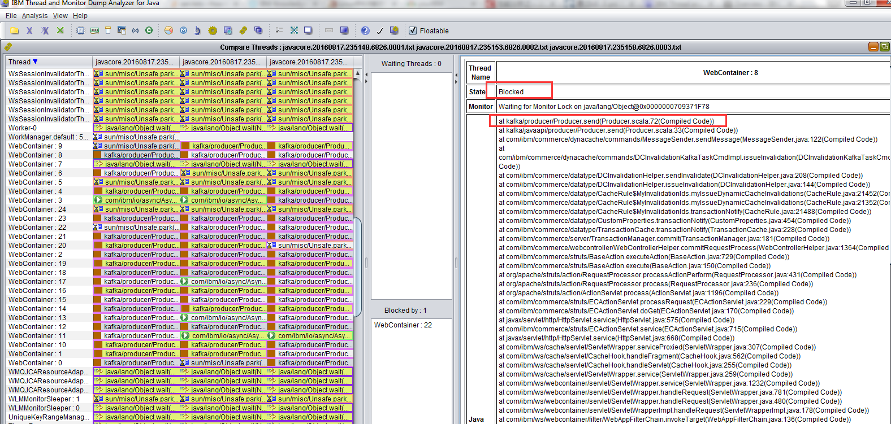

Component directory:
/opt/WebSphere/AppServer/profiles/demo/installedApps/WC_demo_cell/WC_demo.ear/xml/config/com.ibm.commerce.foundation/wc-component.xml

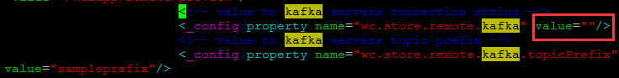

Summary:
This env does not use kafka. And in this wc-component.xml file, the value is null.
(1) So it should not send message to kafka.
(2) Since this thread sends message to kafka, and i do not have kafka server. So no one will receive it, here there is no exceptions for this part to avoid user.

There are 2 problem lies here.

Solution:
打上Patch之后，stress： 20user/ChangeRate5min/SettleTime30min/ThinkTime0
Patch directory:

RPT report:
